|  |  |
| --- | --- |
| Assignment Date | 2 October 2022 |
| Student Name | Neeraja N |
| Student Roll Number | 2019504040 |
| Maximum Marks | 2 Marks |

ASSIGNMENT-3

LED BLINK:(source code)

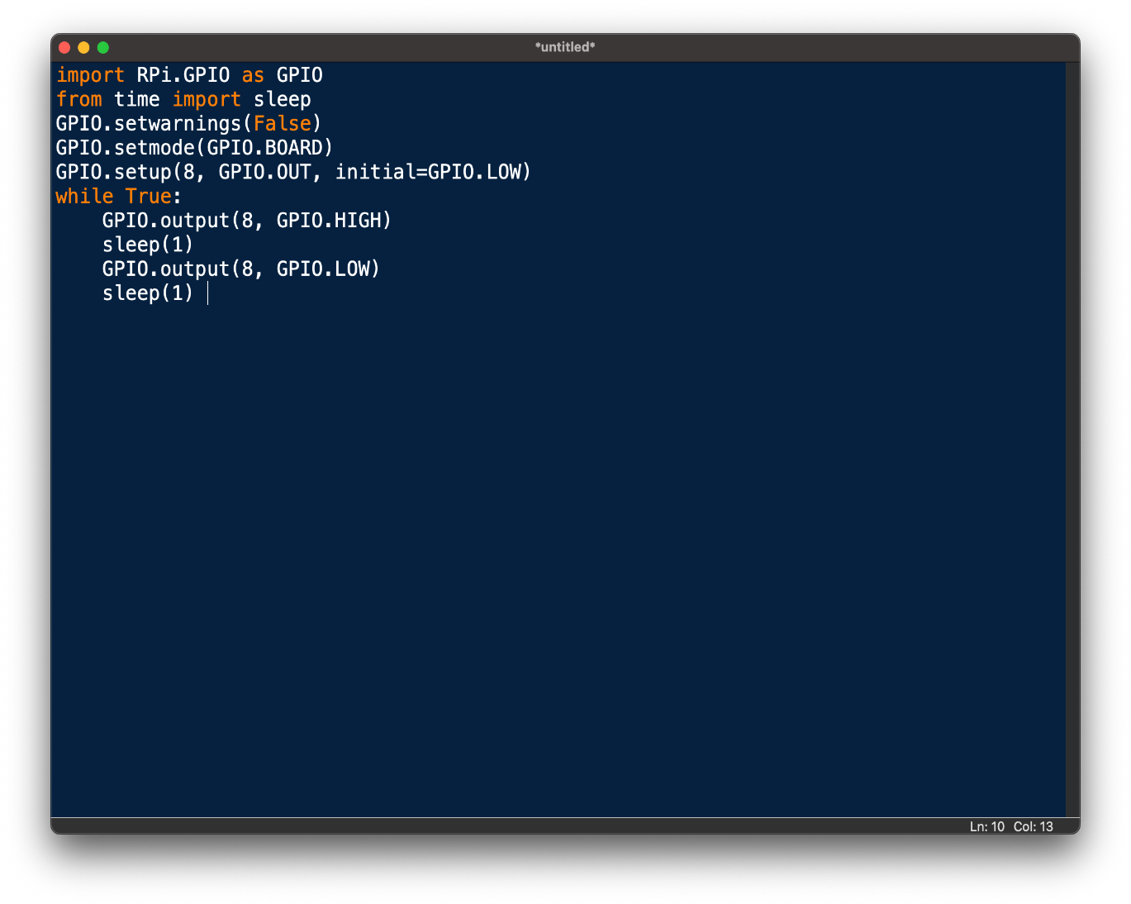

TRAFFIC LIGHT:(source code)

